**ASSINGMENT-1**

**SUBJECT- JAVA**

**UID-22BCS11558**

**NAME-NIKHIL**

1. **PROBLEM 1:- String Analysis (Easy Level)**
2. **CODE:-**

import java.util.Scanner;

public class StringAnalysis {

public static void main(String[] args) {

Scanner scanner = new Scanner(System.in);

System.out.print("Enter a string: ");

String input = scanner.nextLine();

int vowels = 0, consonants = 0, digits = 0, specialChars = 0;

for (char ch : input.toCharArray()) {

if (Character.isLetter(ch)) {

ch = Character.toLowerCase(ch);

if ("aeiou".indexOf(ch) != -1) vowels++;

else consonants++;

} else if (Character.isDigit(ch)) {

digits++;

} else if (!Character.isWhitespace(ch)) {

specialChars++;

}

}

System.out.println("Vowels: " + vowels);

System.out.println("Consonants: " + consonants);

System.out.println("Digits: " + digits);

System.out.println("Special Characters: " + specialChars);

}

}

1. **SCREENSHOT:-**

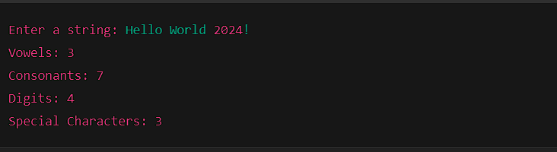

1. **Problem 2: Matrix Operations (Medium Level)**
2. **CODE:-**

import java.util.Scanner;

public class MatrixOperations {

public static void main(String[] args) {

int[][] matrix1 = {

{1, 2},

{3, 4}

};

int[][] matrix2 = {

{5, 6},

{7, 8}

};

int rows = matrix1.length;

int cols = matrix1[0].length;

System.out.println("Addition:");

int[][] addition = new int[rows][cols];

for (int i = 0; i < rows; i++) {

for (int j = 0; j < cols; j++) {

addition[i][j] = matrix1[i][j] + matrix2[i][j];

System.out.print(addition[i][j] + " ");

}

System.out.println();

}

System.out.println("\nSubtraction:");

int[][] subtraction = new int[rows][cols];

for (int i = 0; i < rows; i++) {

for (int j = 0; j < cols; j++) {

subtraction[i][j] = matrix1[i][j] - matrix2[i][j];

System.out.print(subtraction[i][j] + " ");

}

System.out.println();

}

System.out.println("\nMultiplication:");

int[][] multiplication = new int[rows][cols];

for (int i = 0; i < rows; i++) {

for (int j = 0; j < cols; j++) {

multiplication[i][j] = 0;

for (int k = 0; k < cols; k++) {

multiplication[i][j] += matrix1[i][k] * matrix2[k][j];

}

System.out.print(multiplication[i][j] + " ");

}

System.out.println();

}

}

}

1. **SCREENSHOT:-**

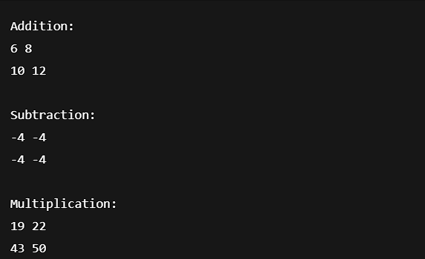

1. **Problem 3: Basic Banking System (Hard Level)**
2. **CODE:-**

class BankAccount {

private String name;

private int accountNumber;

private double balance;

public BankAccount(String name, int accountNumber, double balance) {

this.name = name;

this.accountNumber = accountNumber;

this.balance = balance;

}

public void deposit(double amount) {

if (amount > 0) {

balance += amount;

System.out.println("Deposit successful! Current Balance: " + balance);

}

}

public void withdraw(double amount) {

if (amount > balance) {

System.out.println("Error: Insufficient funds. Current Balance: " + balance);

} else {

balance -= amount;

System.out.println("Withdrawal successful! Current Balance: " + balance);

}

}

public double getBalance() {

return balance;

}

}

public class BankingSystem {

public static void main(String[] args) {

BankAccount account = new BankAccount("John Doe", 12345, 1000);

account.deposit(500); // Deposit

account.withdraw(2000); // Attempt to withdraw more than balance

}

}

1. **SCREENSHOT:-**

